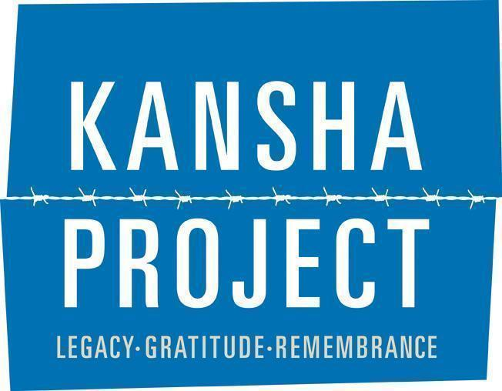

KANSHA ALUMNI LEADERSHIP BOARD INFO SHEET
2025-2026

Application:
What is the Kansha Alumni Leadership Board (ALB)?
The Alumni Leadership Board is an extension of the JACL Chicago program, Kansha Project, that was established in 2015. The Kansha ALB provides an opportunity for meaningful and sustained engagement for Kansha Project participants after they have completed the program. The Kansha ALB will comprise former Kansha Project participants with a high commitment level who can attend monthly in-person planning meetings to shape and implement their vision of the program’s future. While the core mission of the program has continued to act as the foundation, the Kansha Project continues to evolve and change thanks to dedicated alumni. Joining the ALB allows past participants to leave their own stamp on the future of the Kansha Project.

What are the goals of the ALB?
The goal of the Alumni Leadership Board is to ensure the future sustainability of the Kansha Project by providing a structure for young people to move from one-time program recipients to active partners in shaping the future of this program.
Some objectives for the ALB include:
● Developing a shared, youth-driven vision for the future of the Kansha Project and actively working towards that vision
● Creating a curriculum guide for the Kansha Project program
● Engaging Kansha Project alumni in planning and facilitating the program
● Conducting widespread outreach on various platforms to educate the community about the program and expand the participant pool
● Creating a fundraising strategy and plan that aims to diversify and sustain Kansha Project’s funding
● Keeping Kansha Project alumni connected and engaged to each other and to the program

Why should I get involved?
● Re-engage with and shape the future of the Kansha Project.
● Reconnect with participants from your year and meet alumni from other program years.
● Enhance your knowledge of the incarceration experience.
● Gain valuable facilitation, project management, program planning, and leadership skills through ALB professional development trainings and workshops.
● Get connected to and involved with JACL Chicago and the Chicago Japanese American community.

What are the responsibilities/expectations and time commitment of joining the ALB?
As a member of the ALB, you will be part of a group that will plan and implement the Kansha Project. We ask that you commit to being a part of the ALB from December 2025 to September 2026. While roles and responsibilities will vary, the time commitment includes a minimum of 3 - 5 hours per month.

Your exact responsibilities will vary and will be decided once this year’s board is determined and committees have been formed. ALB members are expected to attend monthly in-person board meetings at the JACL Chicago office (5415 N. Clark St.). Please see the calendar below for meeting dates. Depending on your committee, some planning may occur outside of the full board meetings. When applying please keep in mind your schedule for the year and amount of time you are capable of committing to the board.

Committees:
- Each member of the Kansha ALB will join one of the following committees. Please let us know what committee you are most interested in. We will determine committees based on skills, experience, and areas you are interested in growing.

- Program Committee is responsible for the planning/execution of the Kansha Project and facilitates the trip in the summer. Members of this committee will develop skills in project management, communication, curriculum development, and facilitation. In addition to monthly meetings with the ALB, members of this committee will need to meet at least once monthly to plan the Kansha Project and Culmination. Requires high-level of time commitment/capacity.

- Fundraising Committee is responsible for identifying and applying to grants and organizing fundraising events/campaigns for the Kansha ALB like the annual Nisei Lounge Fundraiser. Members of this committee will develop skills in grant writing, event planning, and fundraising. Requires a medium-level of time commitment/capacity.

- Outreach Committee (Communications/Social Media/Alumni Engagement - External Facing) is responsible for developing marketing materials, managing social media platforms, and publicizing fundraising events/campaigns including the Kansha Project application, and culmination. This committee is also responsible for alumni re-engagement and collaborating with other JACL Chicago programs like Next Gen. Nikkei and local Japanese American organizations. Members of this committee should have some prior experience or interest in graphic design and will develop skills in social media management and marketing, event planning and communications. Requires a medium-level of time commitment/capacity.

- Board Development & Historian Committee (Internal Facing): This committee would be responsible for supporting to schedule meetings and planning trainings, take meeting minutes (or delegate to take minutes), send out notes, and assist with planning professional development trainings, workshops, coordinating rotating facilitators, and working with chairs, if desired by individual. This committee will also focus on preservation, management and organization of Kansha culmination projects. Members of this committee will develop skills with administrative and team management in addition to historian/preservation skills Requires a medium-level of time commitment/capacity.

- If you are interested in being involved with Kansha ALB but don't have the capacity to be on a committee or attend monthly events, there are other opportunities for involvement.

Committee Chairs:
Each committee will have a committee chair that will oversee their committee, support committee members, and work more closely with the JACL Chicago Program Director to organize ALB and support board development (ie. helping to brainstorm workshops, trainings, and relationship building on the board). This role is ideal for ALB members that are going on their 2nd (or more) year of ALB to further leadership development. However, new members are also welcome to apply to be committee chairs. Please indicate on the application if you are interested in acting as a committee chair.

Remote support:
If you are unable to attend monthly meetings but still want to support the Kansha Project, the ALB is also looking to fill additional roles that have more flexible timelines where you will be working primarily with the JACL Program Director. These roles include grant writers, graphic designers, historian, tabling volunteers, etc. If you are interested in supporting ALB and the Kansha Project in one of these ways (or another way that is not listed), please still fill out the ALB application.

FAQ
Will I get to go to Little Tokyo and Manzanar again?
Not everyone on the board will be able to attend the trip as a facilitator. Typically the program committee, consisting of 2-3 people, attends as facilitators for the trip. They will work as a group to plan and organize the entire trip’s programming and logistics.

I don’t live in Chicago. Can I still be involved?
We are prioritizing local community engagement however there are many remote roles we are looking to fill. These roles include grant writer, graphic designer, historian, table volunteer, and we’re open to other roles based on your experience and skills. If you are unable to attend in person monthly meetings, please still fill out the application and consider applying for an ALB support/remote role.

Will I be compensated for my participation on Kansha ALB?
At this time, participation in the 2024 Kansha ALB is volunteer-based and unpaid. The goal eventually is for all members of ALB to receive a stipend. We are working to obtain funding to make this possible.

How do I apply?
Applications will open on Wednesday, October 1st and close on Thursday, October 31st at 11:59pm CT. Applicants will be notified by mid-November. The link to apply can be found here and on the JACL Chicago website - www.jaclchicago.org.

Key Dates:
- Kansha ALB Application Deadline: Friday, October 31st, 2024 at 11:59PM
- Board term: December 2025 through September 2026
- Meetings will be held the 3rd Saturday of each month from 11am-1pm (some dates may be subject to change).
- Saturday, December 20th, 2024
- Saturday, January 17th, 2025 - ALB Retreat (mandatory) 11-4pm
- Saturday, February 21st, 2025
- Sunday, February 22nd, 2025 - Day of Remembrance / Kansha Showcase (subject to change)
- Saturday, March 21st, 2025
- Saturday, April 18th, 2025
- Saturday, May 16th, 2025 - ALB Retreat (mandatory) 11-4pm
- Thursday, June 4th- Sunday, June 7th, 2025 (subject to change) - Kansha Project trip to Little Tokyo, LA/Manzanar National Historic Site (mandatory only from Programs Committee)
- Saturday, June 20th
- Saturday, June 28th, 2025 - Kansha Culmination (subject to change - mandatory)
- Saturday, July 18th, 2025
- Saturday, August 15th, 2025
- Saturday, September 19th, 2025

- Additional training and workshops will be announced at a later date and coordinated with the committee.

You must be able to attend monthly meetings, whether they are held remotely or in-person.

Questions? Contact kansha@jaclchicago.org.
